CSA1505-Cloud computing and big data analytics
5-Office Time Off
The Office Time-Off Management System in Zoho Creator simplifies the process of requesting, approving, and tracking employee time-off. Employees can submit leave or time-off requests through an online form by providing details such as departure time, return time, reason for the request, and manager information. Managers can review and approve requests, while all records are securely stored in the cloud for easy access. The system reduces paperwork, improves transparency, maintains accurate leave records, and generates reports to help organizations effectively manage employee availability and attendance.
INPUT
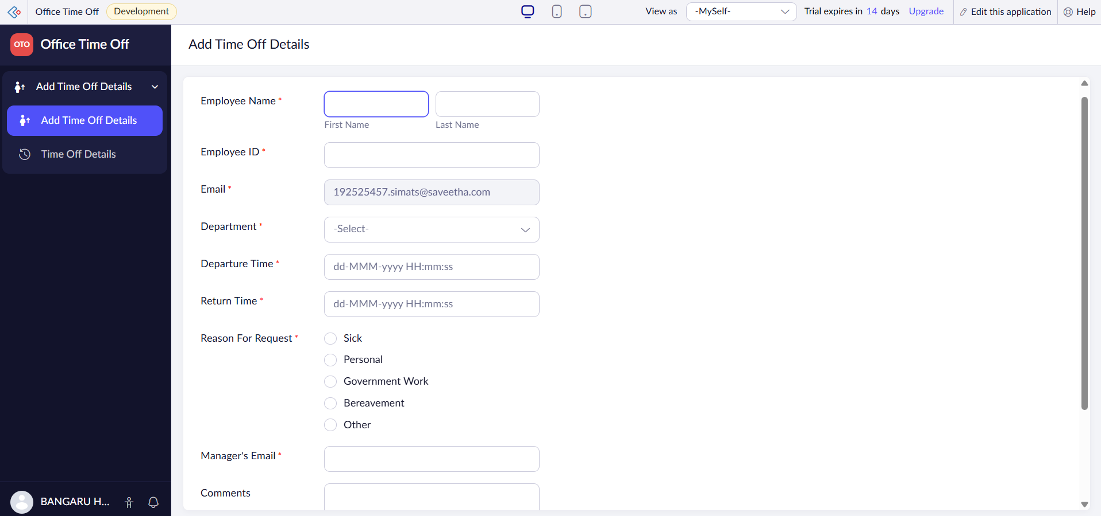

OUTPUT
